Client meetings

First client meeting
  - September 25th
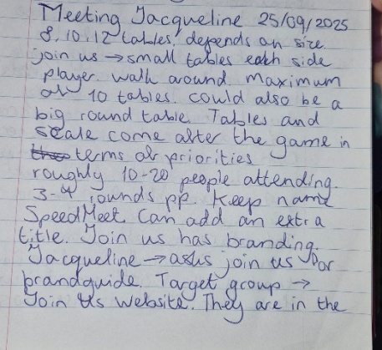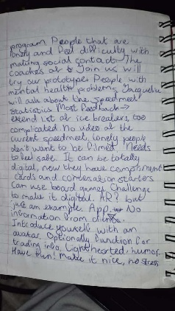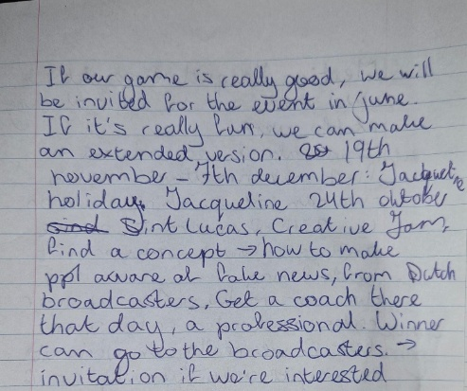
Introduction
The purpose of this meeting was to get to know our client and personally speak to them for the first time and ask our first questions about the project.
Questions first meeting:
- How many tables per round are set up? How many people will roughly attend the SpeedMeet?
Depends how many people join. Maximum is 10 tables, 20 people.
- Do we have complete freedom over the design or do we need to use an already existing brandguide? And do we need to keep the name “SpeedMeet”?
JoinUs has an existing branding, the client is going to ask them if we can adjust it. The name must stay, but we can maybe add a subtitle.
- Is there an already existing target audience definition?
Young lonely people age 18 – 22. JoinUs is an organisation where these kind of people can join together doing activities to help their social anxiety and to help feel less lonely.
- Is there an existing document of statistics about the current SpeedMeet?
Jacqueline will ask JoinUs about the SpeedMeet Statistics and feedback. Some of the most important feedback was to extend the list of icebreakers, make them less complicated and really make them based on what the target audience would enjoy. Make it so that they feel it’s fun to have a conversation.
- Is there a video about the current SpeedMeet?
There is no video, because the people attending the SpeedMeet highly dislike being filmed.
- How many digital and physical aspects do you want?
We can make everything digital. We can also make physical aspects, but as we are Fontys ICT, being creative with making it digital and make it an app would be preferable. Make it stress-free and fun. Examples: make avatars, make the timers fun, conversation cards in the app, maybe AR.
Extra takeaways
As our target audience dislikes being filmed and struggle with social anxiety, we need to focus on making the game fun, lighthearted and safe. If JoinUs thinks our game is really good after the event, we’ll be invited to the big event with the real target audience in June. From November 19th – December 7th Jacqueline will be on holiday.

Second client meeting
  - October 2nd
Introduction
The purpose of this meeting was to pitch the concepts and ideas we had and get feedback on which concepts she prefers and what elements she likes. This way we’re able to see which direction to go.
Pitched concepts
- Campfire with fishing
Players take on the role of scouts gathered around a campfire near a large lake. The Game Master becomes the “fisher”, casting into the lake and pulling out icebreaker prompts. Each scout sits one-on-one at their own campfire, roasting marshmallows. Each phase the marshmallow roasts more, once it's completely roasted, the round is over and it's time to switch partners.
- Beach
Players share a picnic on the beach as seashells wash up on shore. Each picnic is one table to sit at one-on-one. The Game Master plays the role of a crab walking by, carrying the icebreaker prompts. Time is tracked visually, either with a beach ball bouncing along the sand or with a boat sailing steadily across the water, reaching checkpoints for each round.
- Lakeside
Players are frogs perched on lily pads, which serve as their “tables”. The Game Master is a giant frog, hopping to a pad. When it’s time for a new icebreaker, water splashes up with the prompt, or the big frog uses its tongue to pull the icebreaker in the view. The timer is shown through lily flowers that bloom until the round ends. Each phase is a different blooming stage from the flowers.
She liked the concept of the campfire the most as it gives the cozy feeling she is looking for, but likes the silliness of the frogs. She liked the roasting marshmallow as a timer and having them out in nature on a fireplace as it is very bonding type of experience.
Questions and answers
- Do you think it is good to mention that a round is going to last 10 min when someone is about to join the session?
  - Putting herself in the shoes of the players she does agree that would be quite good to mention how long it would take for the game, as the whole event is about 3-4 hours, and the game itself can be time consuming
- How many icebreakers do you consider enough?
  - They already have three Icebreakers, and she thinks we can add 5 more to have some more diversity, but we have to user-test them before the actual event to make sure they are fine to be included in it.

Third client meeting
  - October 22nd
Introduction
The purpose of this meeting was to check in with the client to see if we we’re on the right track, to update her on what we’re doing, gather feedback and see if something else could be added.
Content
We mainly showed her the updated idea of the Campfire concept, which is the cats sitting in duos around the campfire with a roasting fish as a timer and randomization of seats/partner switching.
The feedback we got was to take vegetarians into consideration, see if they’re okay with a roasting fish. We are able to test the partner switch on the event, test if it works or if it needs fixing. We can make posters with a QR code to connect to the game and put them on the big screen. We need to test if we can work with an automated website or if we need a gamemaster. A script is also needed for the host if JoinUs wants to use the game. It needs to have a warm welcome, an introduction and a manual, so they don’t need our help every time they want to play. Don’t make the icebreakers too complicated. Try to test simple ones, that don’t require physical contact. Make it relaxing.
Extra takeaways:
Right now we need to focus on making and testing the icebreakers and conversation starters. We will start testing with 6 tables (12 players) at the event. We need to plan some time to check in with the players for feedback and see if everything works. Jacqueline has made a list of stuff we need at the event and will ask JoinUs about the space.
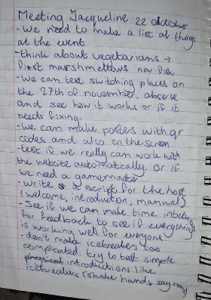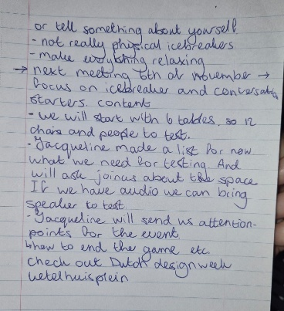

Fourth client meeting
  - November 6th
Introduction
The purpose of this meeting was to discuss what we have planned for the event, get informed about the status of the things we need at the event and gain some more feedback.
Takeaways
We got some feedback to ask JoinUs about the logo after the event. The client is fine with the change of prototype and she informed us that the players will be playing on tall standing tables. We need to inform the players that this is a prototype and not yet the real thing. It would be nice to have a big standing table for design feedback. If no one wants to play, walk around and invite people in. it’s good to have a master table to switch al the phone screens. If we want audio, it’s best to look into sound design. We get a screen at the event that also has audio. We’re asking Pennie to get fontys shirts. It’s god to have a dresscode. The client was happy that we usertested the icebreakers and conversation starters. We need to figure out what the next steps are to better the script and manual in terms of the new version of the prototype

  - 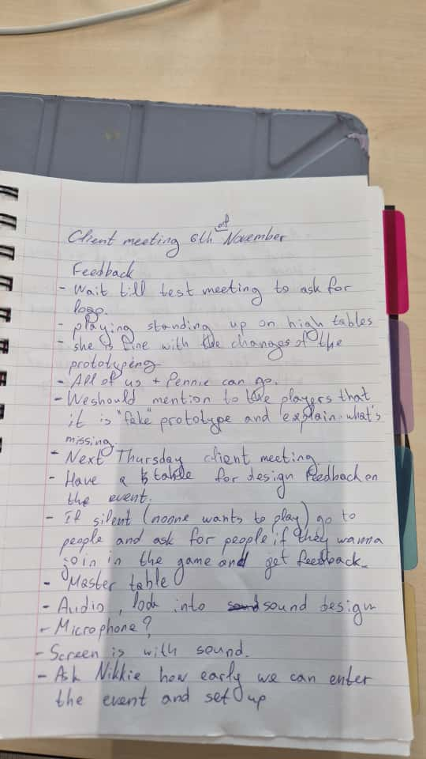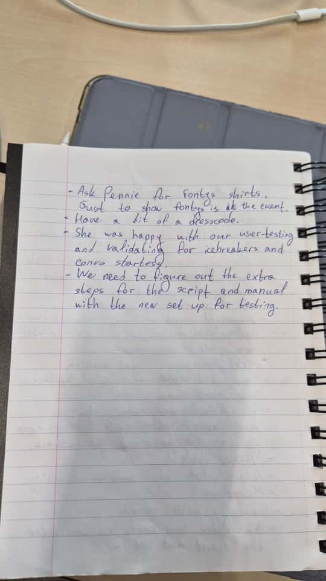

Fifth client meeting
  - November 13th
Introduction
The purpose of this meeting was to have a last check in with the client before the event and to ask some last questions.
Takeaways
There’s a lot of time between our arrival, setting up and the visitors arriving. It’s recommended for us to be assertive and really get people to play. It would be preferable if the game is in Dutch as the people attending the event will all be Dutch. If we have any more questions about technical specs, we can ask via e-mail and for other questions, we can ask Pennie, as she has the contact information of Nikkie.
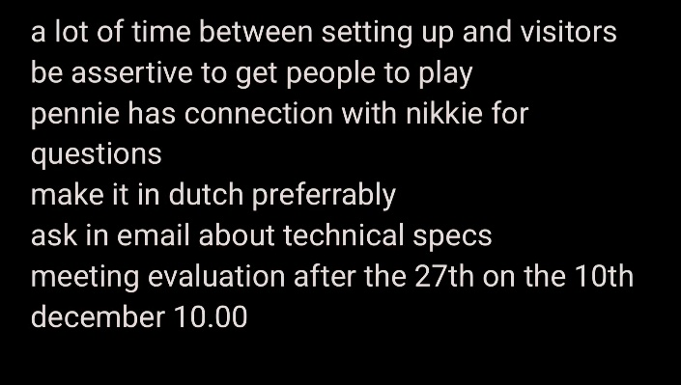

Sixth client meeting
  - December 10th
Introduction
This meeting served as a recap and to discuss with the client what we experienced at the event and how everything went.
Takeaways
The client was very pleased with how the event went. We need to send her the feedback from the questionnaire, show the highs and lows and write conclusions. We also need to find out what the best setting would be for the game. Test if it’s better in an open area or in a room. We also need to see how the automated process functions and back the choices up with the conclusions. It’s good that the players liked the game and only walked away because of the schedule. We found out that stickers are a good motivator to join the game. We got permission from the client to play around with the time of some of the phases of the speedmeet. It’s also a good idea to have someone walking around to invite people to play. We need to show pictures of the event during the final presentation. We need to send Jacqueline our design and help her catch up on all our work since last meeting. If we get the option to choose between playing the game and presenting, it would be better to play the game.
